<h2 data-tool="mdnice编辑器" style="margin-top: 30px; padding: 0px; font-weight: bold; font-size: 22px; border-bottom: 2px solid rgb(89,89,89); margin-bottom: 5px; color: rgb(89,89,89);"><span class="content" style="font-size: 22px; display: inline-block; border-bottom: 2px solid rgb(89,89,89);">📖好文章</span></h2>

<ul data-tool="mdnice编辑器" style="margin-top: 4px; margin-bottom: 4px; padding-left: 25px; color: black; list-style-type: disc;"><li><section style="margin-top: 5px; margin-bottom: 5px; line-height: 26px; text-align: left; color: rgb(1,1,1); font-weight: 500;">📄什么黑科技？纯血鸿蒙又可以运行Android应用了！</section><p data-tool="mdnice编辑器" style="font-size: 16px; padding-top: 8px; padding-bottom: 8px; margin: 0; line-height: 26px; color: rgb(89,89,89);"><strong style="font-weight: bold; color: rgb(71, 193, 168);">https://juejin.cn/post/7448576110823047202</strong></p></li><li><section style="margin-top: 5px; margin-bottom: 5px; line-height: 26px; text-align: left; color: rgb(1,1,1); font-weight: 500;">📄桌面挂件不能承受之重——GIF</section><p data-tool="mdnice编辑器" style="font-size: 16px; padding-top: 8px; padding-bottom: 8px; margin: 0; line-height: 26px; color: rgb(89,89,89);"><strong style="font-weight: bold; color: rgb(71, 193, 168);">https://juejin.cn/post/7540565683060015167</strong></p></li><li><section style="margin-top: 5px; margin-bottom: 5px; line-height: 26px; text-align: left; color: rgb(1,1,1); font-weight: 500;">📄Flutter 性能监控实践</section><p data-tool="mdnice编辑器" style="font-size: 16px; padding-top: 8px; padding-bottom: 8px; margin: 0; line-height: 26px; color: rgb(89,89,89);"><strong style="font-weight: bold; color: rgb(71, 193, 168);">https://xie.infoq.cn/article/cb55a36e852056db35b0c0b51</strong></p></li></ul>

<h2 data-tool="mdnice编辑器" style="margin-top: 30px; padding: 0px; font-weight: bold; font-size: 22px; border-bottom: 2px solid rgb(89,89,89); margin-bottom: 5px; color: rgb(89,89,89);"><span class="content" style="font-size: 22px; display: inline-block; border-bottom: 2px solid rgb(89,89,89);">📚好资源</span></h2>

<h3 data-tool="mdnice编辑器" style="margin-top: 30px; margin-bottom: 15px; padding: 0px; font-weight: bold; font-size: 20px; color: rgb(89,89,89);"><span class="prefix" style="display: none;"></span><span class="content">mangadex</span></h3>

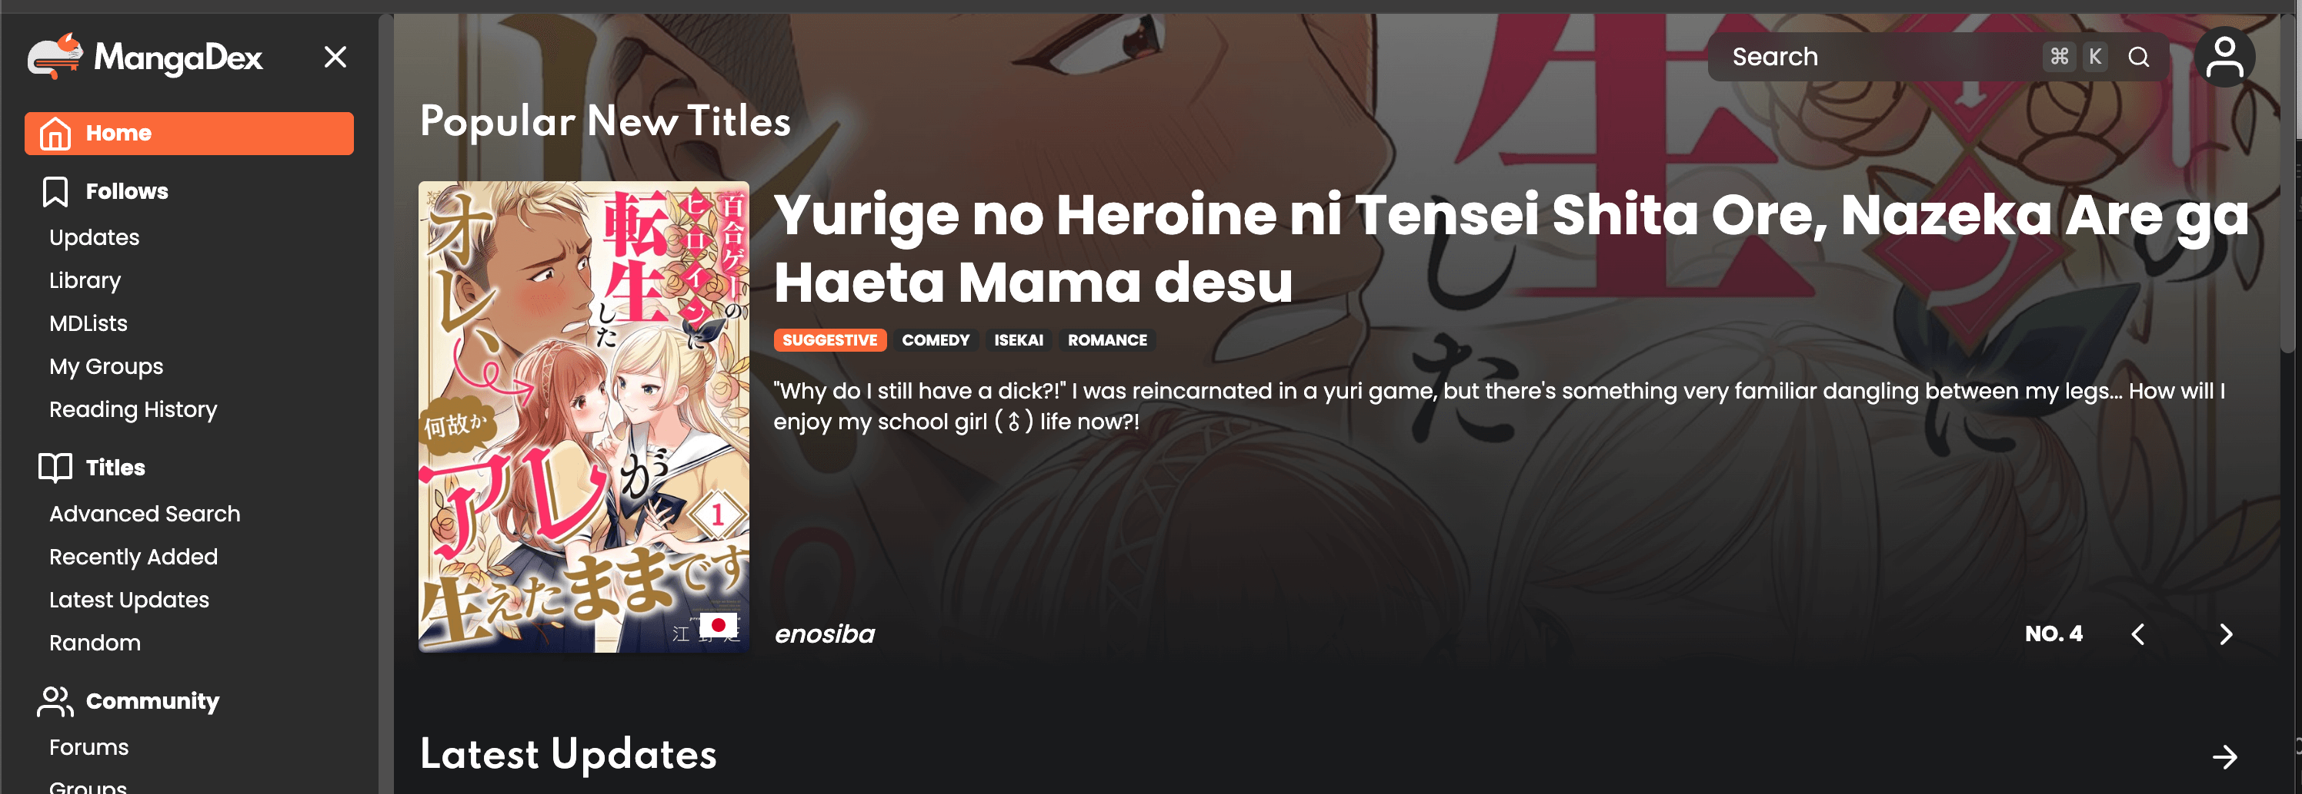

<p data-tool="mdnice编辑器" style="font-size: 16px; padding-top: 8px; padding-bottom: 8px; margin: 0; line-height: 26px; color: rgb(89,89,89);"><strong style="font-weight: bold; color: rgb(71, 193, 168);">https://mangadex.org/</strong></p>

<p data-tool="mdnice编辑器" style="font-size: 16px; padding-top: 8px; padding-bottom: 8px; margin: 0; line-height: 26px; color: black;">漫画相关</p>

<h3 data-tool="mdnice编辑器" style="margin-top: 30px; margin-bottom: 15px; padding: 0px; font-weight: bold; font-size: 20px; color: rgb(89,89,89);"><span class="prefix" style="display: none;"></span><span class="content">kox.moe</span></h3>

<p data-tool="mdnice编辑器" style="font-size: 16px; padding-top: 8px; padding-bottom: 8px; margin: 0; line-height: 26px; color: rgb(89,89,89);"><strong style="font-weight: bold; color: rgb(71, 193, 168);">https://kox.moe/</strong></p>

<p data-tool="mdnice编辑器" style="font-size: 16px; padding-top: 8px; padding-bottom: 8px; margin: 0; line-height: 26px; color: black;">漫画书</p>

<h3 data-tool="mdnice编辑器" style="margin-top: 30px; margin-bottom: 15px; padding: 0px; font-weight: bold; font-size: 20px; color: rgb(89,89,89);"><span class="prefix" style="display: none;"></span><span class="content">thestocks</span></h3>

<p data-tool="mdnice编辑器" style="font-size: 16px; padding-top: 8px; padding-bottom: 8px; margin: 0; line-height: 26px; color: rgb(89,89,89);"><strong style="font-weight: bold; color: rgb(71, 193, 168);">https://thestocks.im/</strong></p>

<p data-tool="mdnice编辑器" style="font-size: 16px; padding-top: 8px; padding-bottom: 8px; margin: 0; line-height: 26px; color: black;">设计素材网址合集</p>

<h2 data-tool="mdnice编辑器" style="margin-top: 30px; padding: 0px; font-weight: bold; font-size: 22px; border-bottom: 2px solid rgb(89,89,89); margin-bottom: 5px; color: rgb(89,89,89);"><span class="content" style="font-size: 22px; display: inline-block; border-bottom: 2px solid rgb(89,89,89);">🔨好工具</span></h2>

<h3 data-tool="mdnice编辑器" style="margin-top: 30px; margin-bottom: 15px; padding: 0px; font-weight: bold; font-size: 20px; color: rgb(89,89,89);"><span class="prefix" style="display: none;"></span><span class="content">paywallbuster</span></h3>

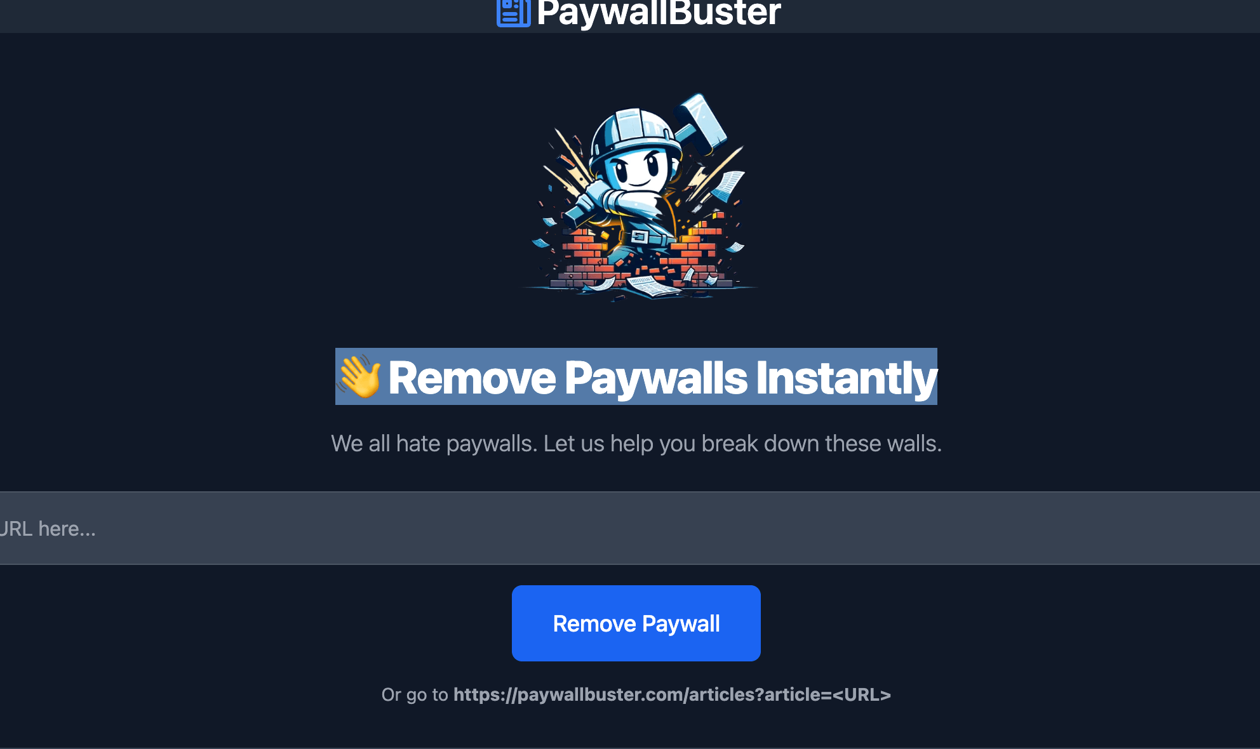

<p data-tool="mdnice编辑器" style="font-size: 16px; padding-top: 8px; padding-bottom: 8px; margin: 0; line-height: 26px; color: rgb(89,89,89);"><strong style="font-weight: bold; color: rgb(71, 193, 168);">https://paywallbuster.com/</strong></p>

<p data-tool="mdnice编辑器" style="font-size: 16px; padding-top: 8px; padding-bottom: 8px; margin: 0; line-height: 26px; color: black;">👋 Remove Paywalls Instantly</p>

<h3 data-tool="mdnice编辑器" style="margin-top: 30px; margin-bottom: 15px; padding: 0px; font-weight: bold; font-size: 20px; color: rgb(89,89,89);"><span class="prefix" style="display: none;"></span><span class="content">nano banana ai</span></h3>

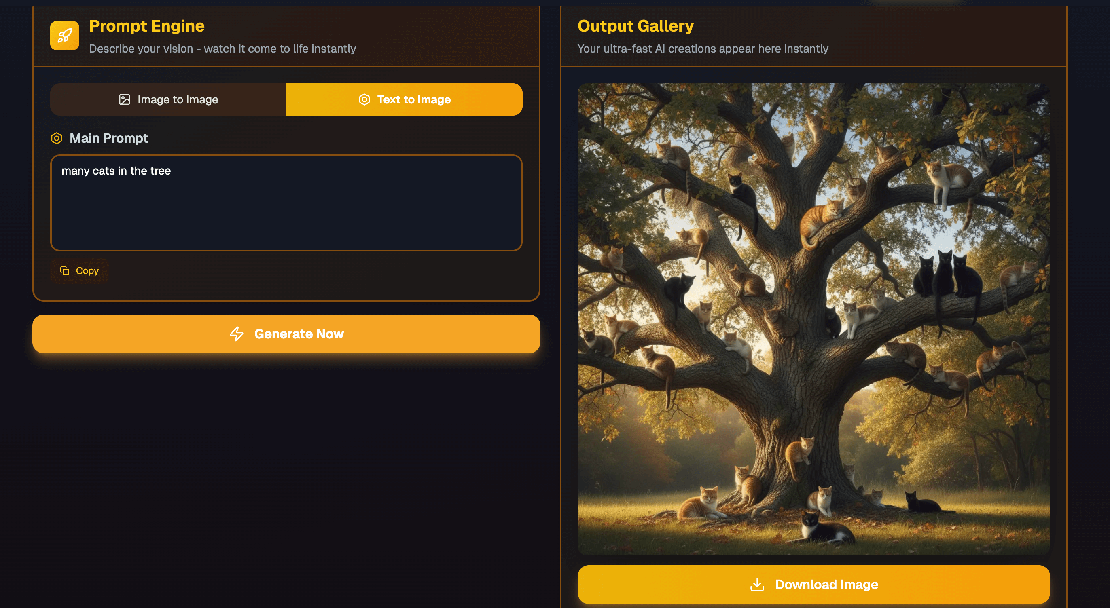

<p data-tool="mdnice编辑器" style="font-size: 16px; padding-top: 8px; padding-bottom: 8px; margin: 0; line-height: 26px; color: rgb(89,89,89);"><strong style="font-weight: bold; color: rgb(71, 193, 168);">https://nanobanana.ai/</strong></p>

<p data-tool="mdnice编辑器" style="font-size: 16px; padding-top: 8px; padding-bottom: 8px; margin: 0; line-height: 26px; color: black;">Transform any image with simple text prompts. Nano-banana's advanced model delivers consistent character editing and scene preservation that surpasses Flux Kontext. Experience the future of AI image editing.</p>

<p data-tool="mdnice编辑器" style="font-size: 16px; padding-top: 8px; padding-bottom: 8px; margin: 0; line-height: 26px; color: black;">Google近期最新发布的图像生成模型nano banana。</p>

<h3 data-tool="mdnice编辑器" style="margin-top: 30px; margin-bottom: 15px; padding: 0px; font-weight: bold; font-size: 20px; color: rgb(89,89,89);"><span class="prefix" style="display: none;"></span><span class="content">lmarena.ai</span></h3>

<p data-tool="mdnice编辑器" style="font-size: 16px; padding-top: 8px; padding-bottom: 8px; margin: 0; line-height: 26px; color: rgb(89,89,89);"><strong style="font-weight: bold; color: rgb(71, 193, 168);">https://web.lmarena.ai/</strong></p>

<p data-tool="mdnice编辑器" style="font-size: 16px; padding-top: 8px; padding-bottom: 8px; margin: 0; line-height: 26px; color: black;">WebDev Arena is a real-time AI coding competition where models go head-to-head in web development challenges, developed by LMArena. We always welcome contributions from the community. If you're interested in collaboration, we'd love to hear from you!</p>

<h3 data-tool="mdnice编辑器" style="margin-top: 30px; margin-bottom: 15px; padding: 0px; font-weight: bold; font-size: 20px; color: rgb(89,89,89);"><span class="prefix" style="display: none;"></span><span class="content">中国家谱知识服务平台</span></h3>

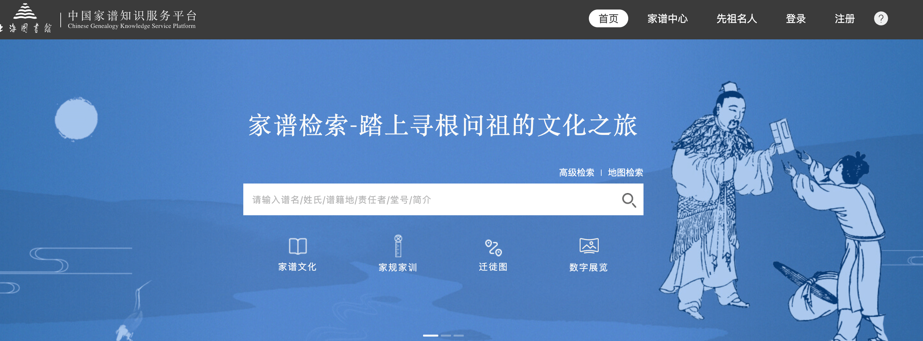

<p data-tool="mdnice编辑器" style="font-size: 16px; padding-top: 8px; padding-bottom: 8px; margin: 0; line-height: 26px; color: rgb(89,89,89);"><strong style="font-weight: bold; color: rgb(71, 193, 168);">https://jiapu.library.sh.cn/#/</strong></p>

<p data-tool="mdnice编辑器" style="font-size: 16px; padding-top: 8px; padding-bottom: 8px; margin: 0; line-height: 26px; color: black;">认祖归宗，家谱查询。踏上寻根问祖的文化之旅。</p>

<h2 data-tool="mdnice编辑器" style="margin-top: 30px; padding: 0px; font-weight: bold; font-size: 22px; border-bottom: 2px solid rgb(89,89,89); margin-bottom: 5px; color: rgb(89,89,89);"><span class="content" style="font-size: 22px; display: inline-block; border-bottom: 2px solid rgb(89,89,89);">🎮好玩的</span></h2>

<h3 data-tool="mdnice编辑器" style="margin-top: 30px; margin-bottom: 15px; padding: 0px; font-weight: bold; font-size: 20px; color: rgb(89,89,89);"><span class="prefix" style="display: none;"></span><span class="content">arrival.space</span></h3>

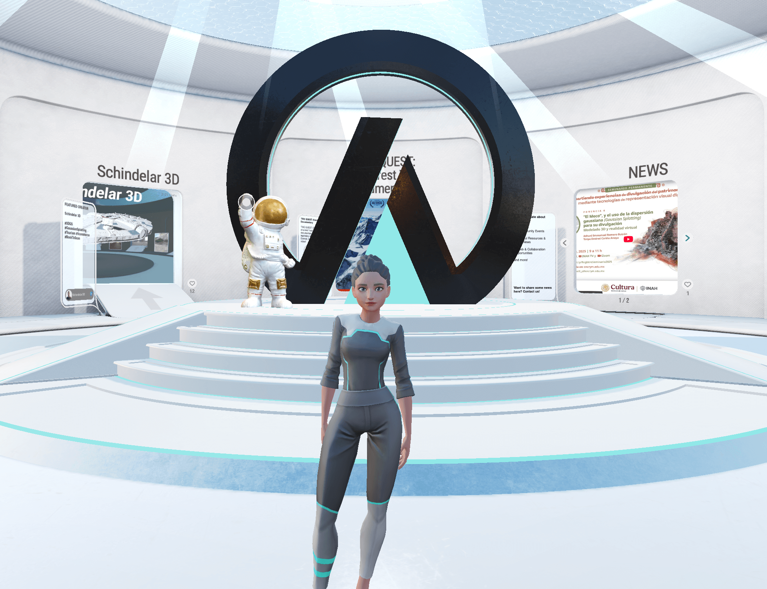

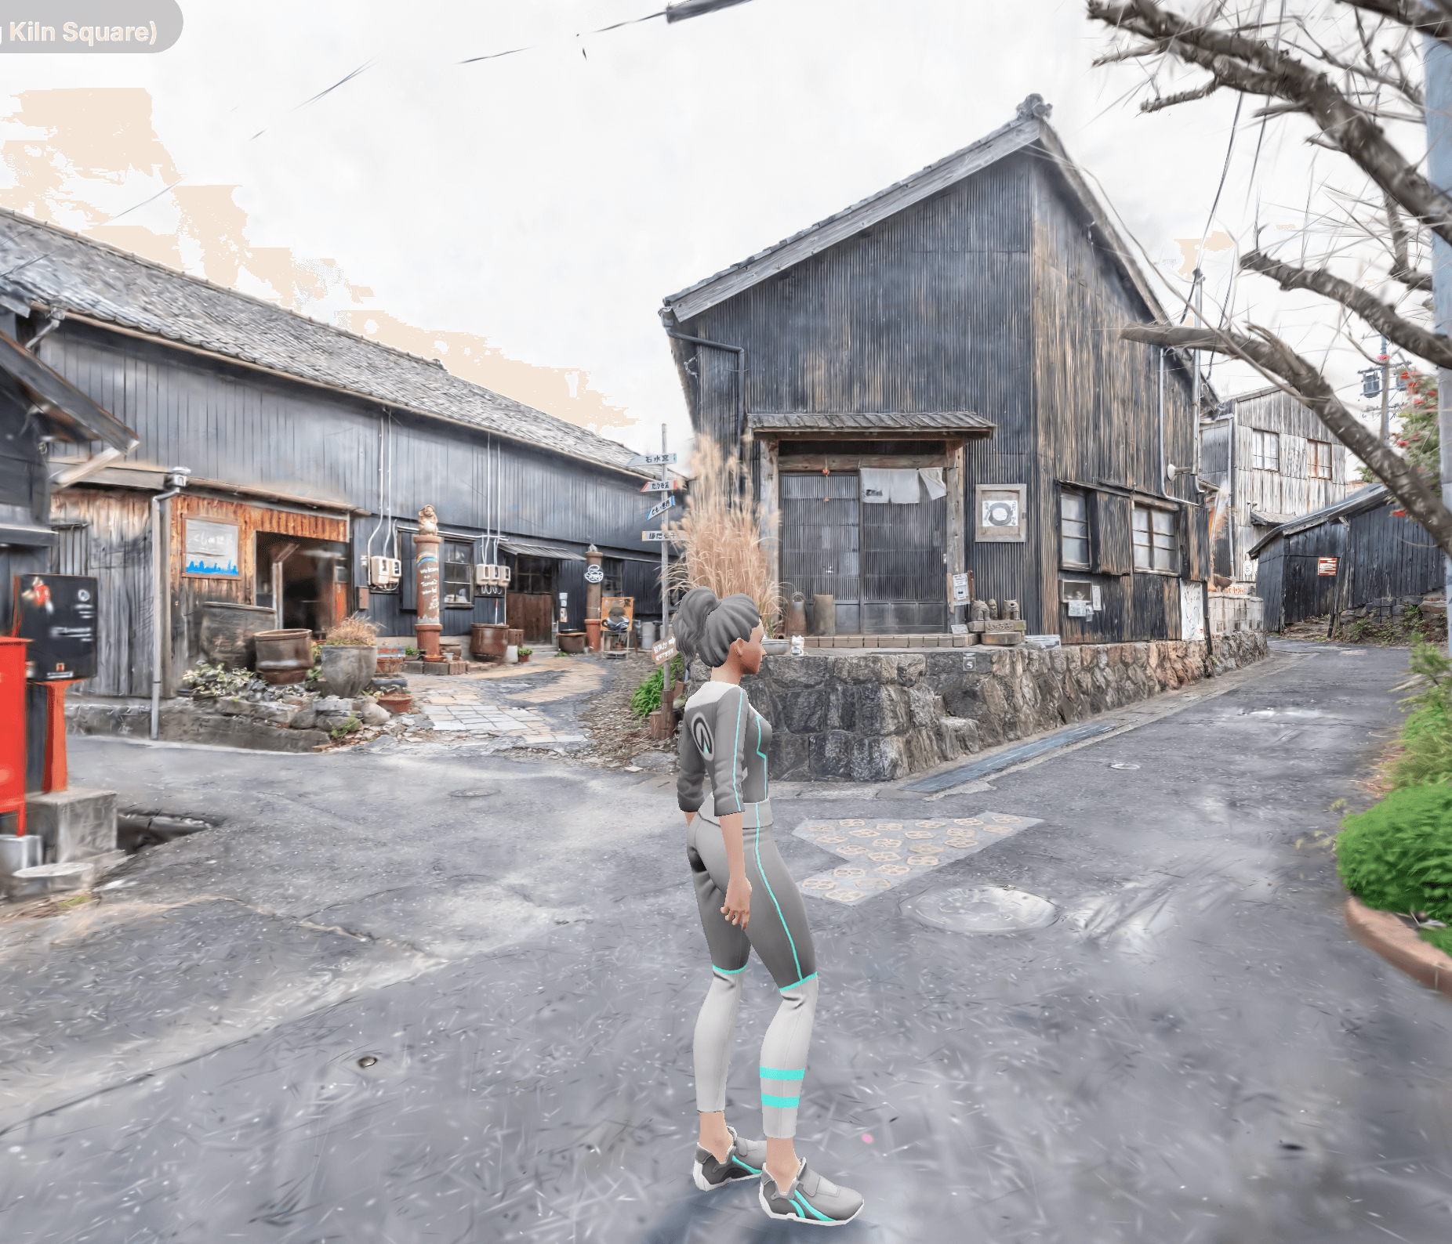

<p data-tool="mdnice编辑器" style="font-size: 16px; padding-top: 8px; padding-bottom: 8px; margin: 0; line-height: 26px; color: rgb(89,89,89);"><strong style="font-weight: bold; color: rgb(71, 193, 168);">https://arrival.space/</strong></p>

<p data-tool="mdnice编辑器" style="font-size: 16px; padding-top: 8px; padding-bottom: 8px; margin: 0; line-height: 26px; color: black;">基于浏览器的互操作性3D平台。其中有一个日本实景街道渲染，没去过日本实现云逛街。</p>

<h3 data-tool="mdnice编辑器" style="margin-top: 30px; margin-bottom: 15px; padding: 0px; font-weight: bold; font-size: 20px; color: rgb(89,89,89);"><span class="prefix" style="display: none;"></span><span class="content">dversostudio</span></h3>

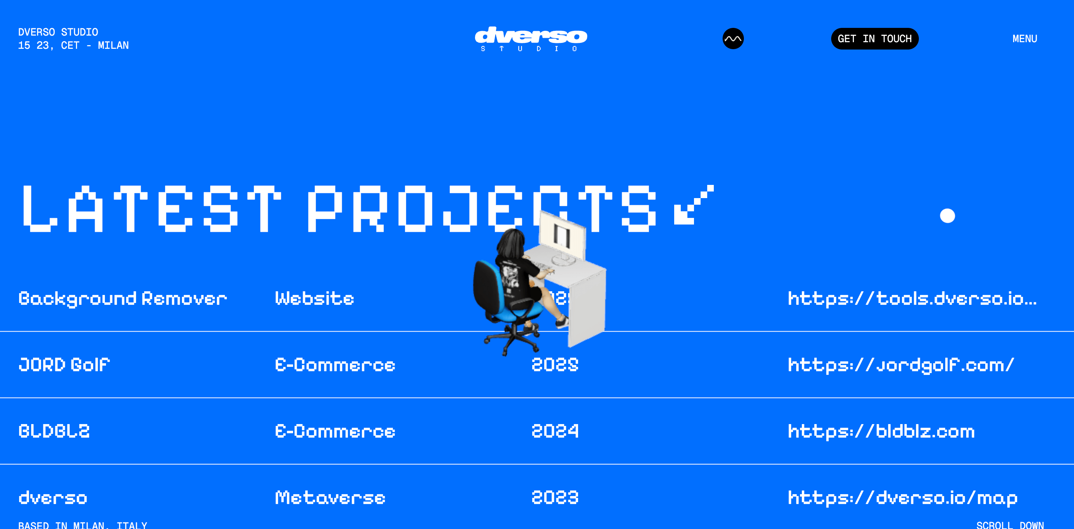

<p data-tool="mdnice编辑器" style="font-size: 16px; padding-top: 8px; padding-bottom: 8px; margin: 0; line-height: 26px; color: rgb(89,89,89);"><strong style="font-weight: bold; color: rgb(71, 193, 168);">https://dversostudio.io/</strong></p>

<p data-tool="mdnice编辑器" style="font-size: 16px; padding-top: 8px; padding-bottom: 8px; margin: 0; line-height: 26px; color: black;">Discover Dverso, the free 3D metaverse editor offering real-time collaboration for crafting immersive web virtual world experiences in your browser.</p>

<p data-tool="mdnice编辑器" style="font-size: 16px; padding-top: 8px; padding-bottom: 8px; margin: 0; line-height: 26px; color: black;">一个炫酷的前端网址</p>

<h3 data-tool="mdnice编辑器" style="margin-top: 30px; margin-bottom: 15px; padding: 0px; font-weight: bold; font-size: 20px; color: rgb(89,89,89);"><span class="prefix" style="display: none;"></span><span class="content">tools.dverso.io - bgremove</span></h3>

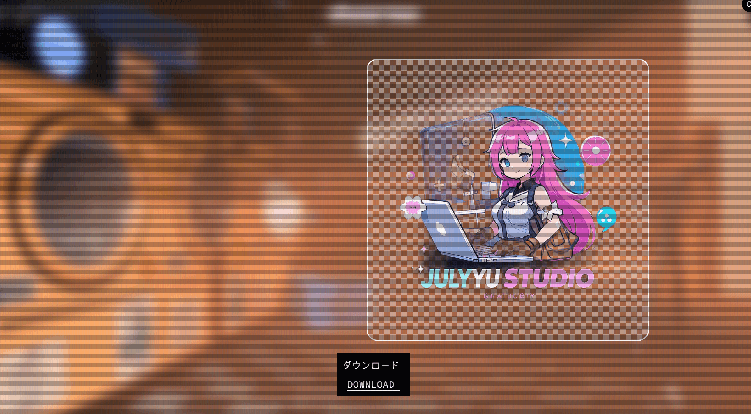

<p data-tool="mdnice编辑器" style="font-size: 16px; padding-top: 8px; padding-bottom: 8px; margin: 0; line-height: 26px; color: rgb(89,89,89);"><strong style="font-weight: bold; color: rgb(71, 193, 168);">https://tools.dverso.io/bgremove/</strong></p>

<p data-tool="mdnice编辑器" style="font-size: 16px; padding-top: 8px; padding-bottom: 8px; margin: 0; line-height: 26px; color: black;">tools.dverso.io 是个能去掉图片背景的网站，它的特别之处是把抠图过程做成了好玩的洗衣游戏。你把图片拖到网页上，它会变成一件虚拟衣服，自动丢进洗衣机，洗衣机门关上后开始转，还有转动的声音。等洗衣机停了，就能下载去掉背景的图片。</p>